Intech Grid Specification
Top-level Design Overview

Grid Modules
The Grid Modules are Human Interface Devices designed to provide an affirmative, tactile user experience, allowing creatives to interact with the computer more naturally and efficiently. Grid Modules are 4.2” wide, while user interface components are placed in a 1.05” raster layout. This allows multiple modules to create one seamless user interface. The modules can be connected in any order and orientation using a custom designed magnetic interface. Grid is designed to be portable, affordable and flexible, following the requirements set by the creative community.
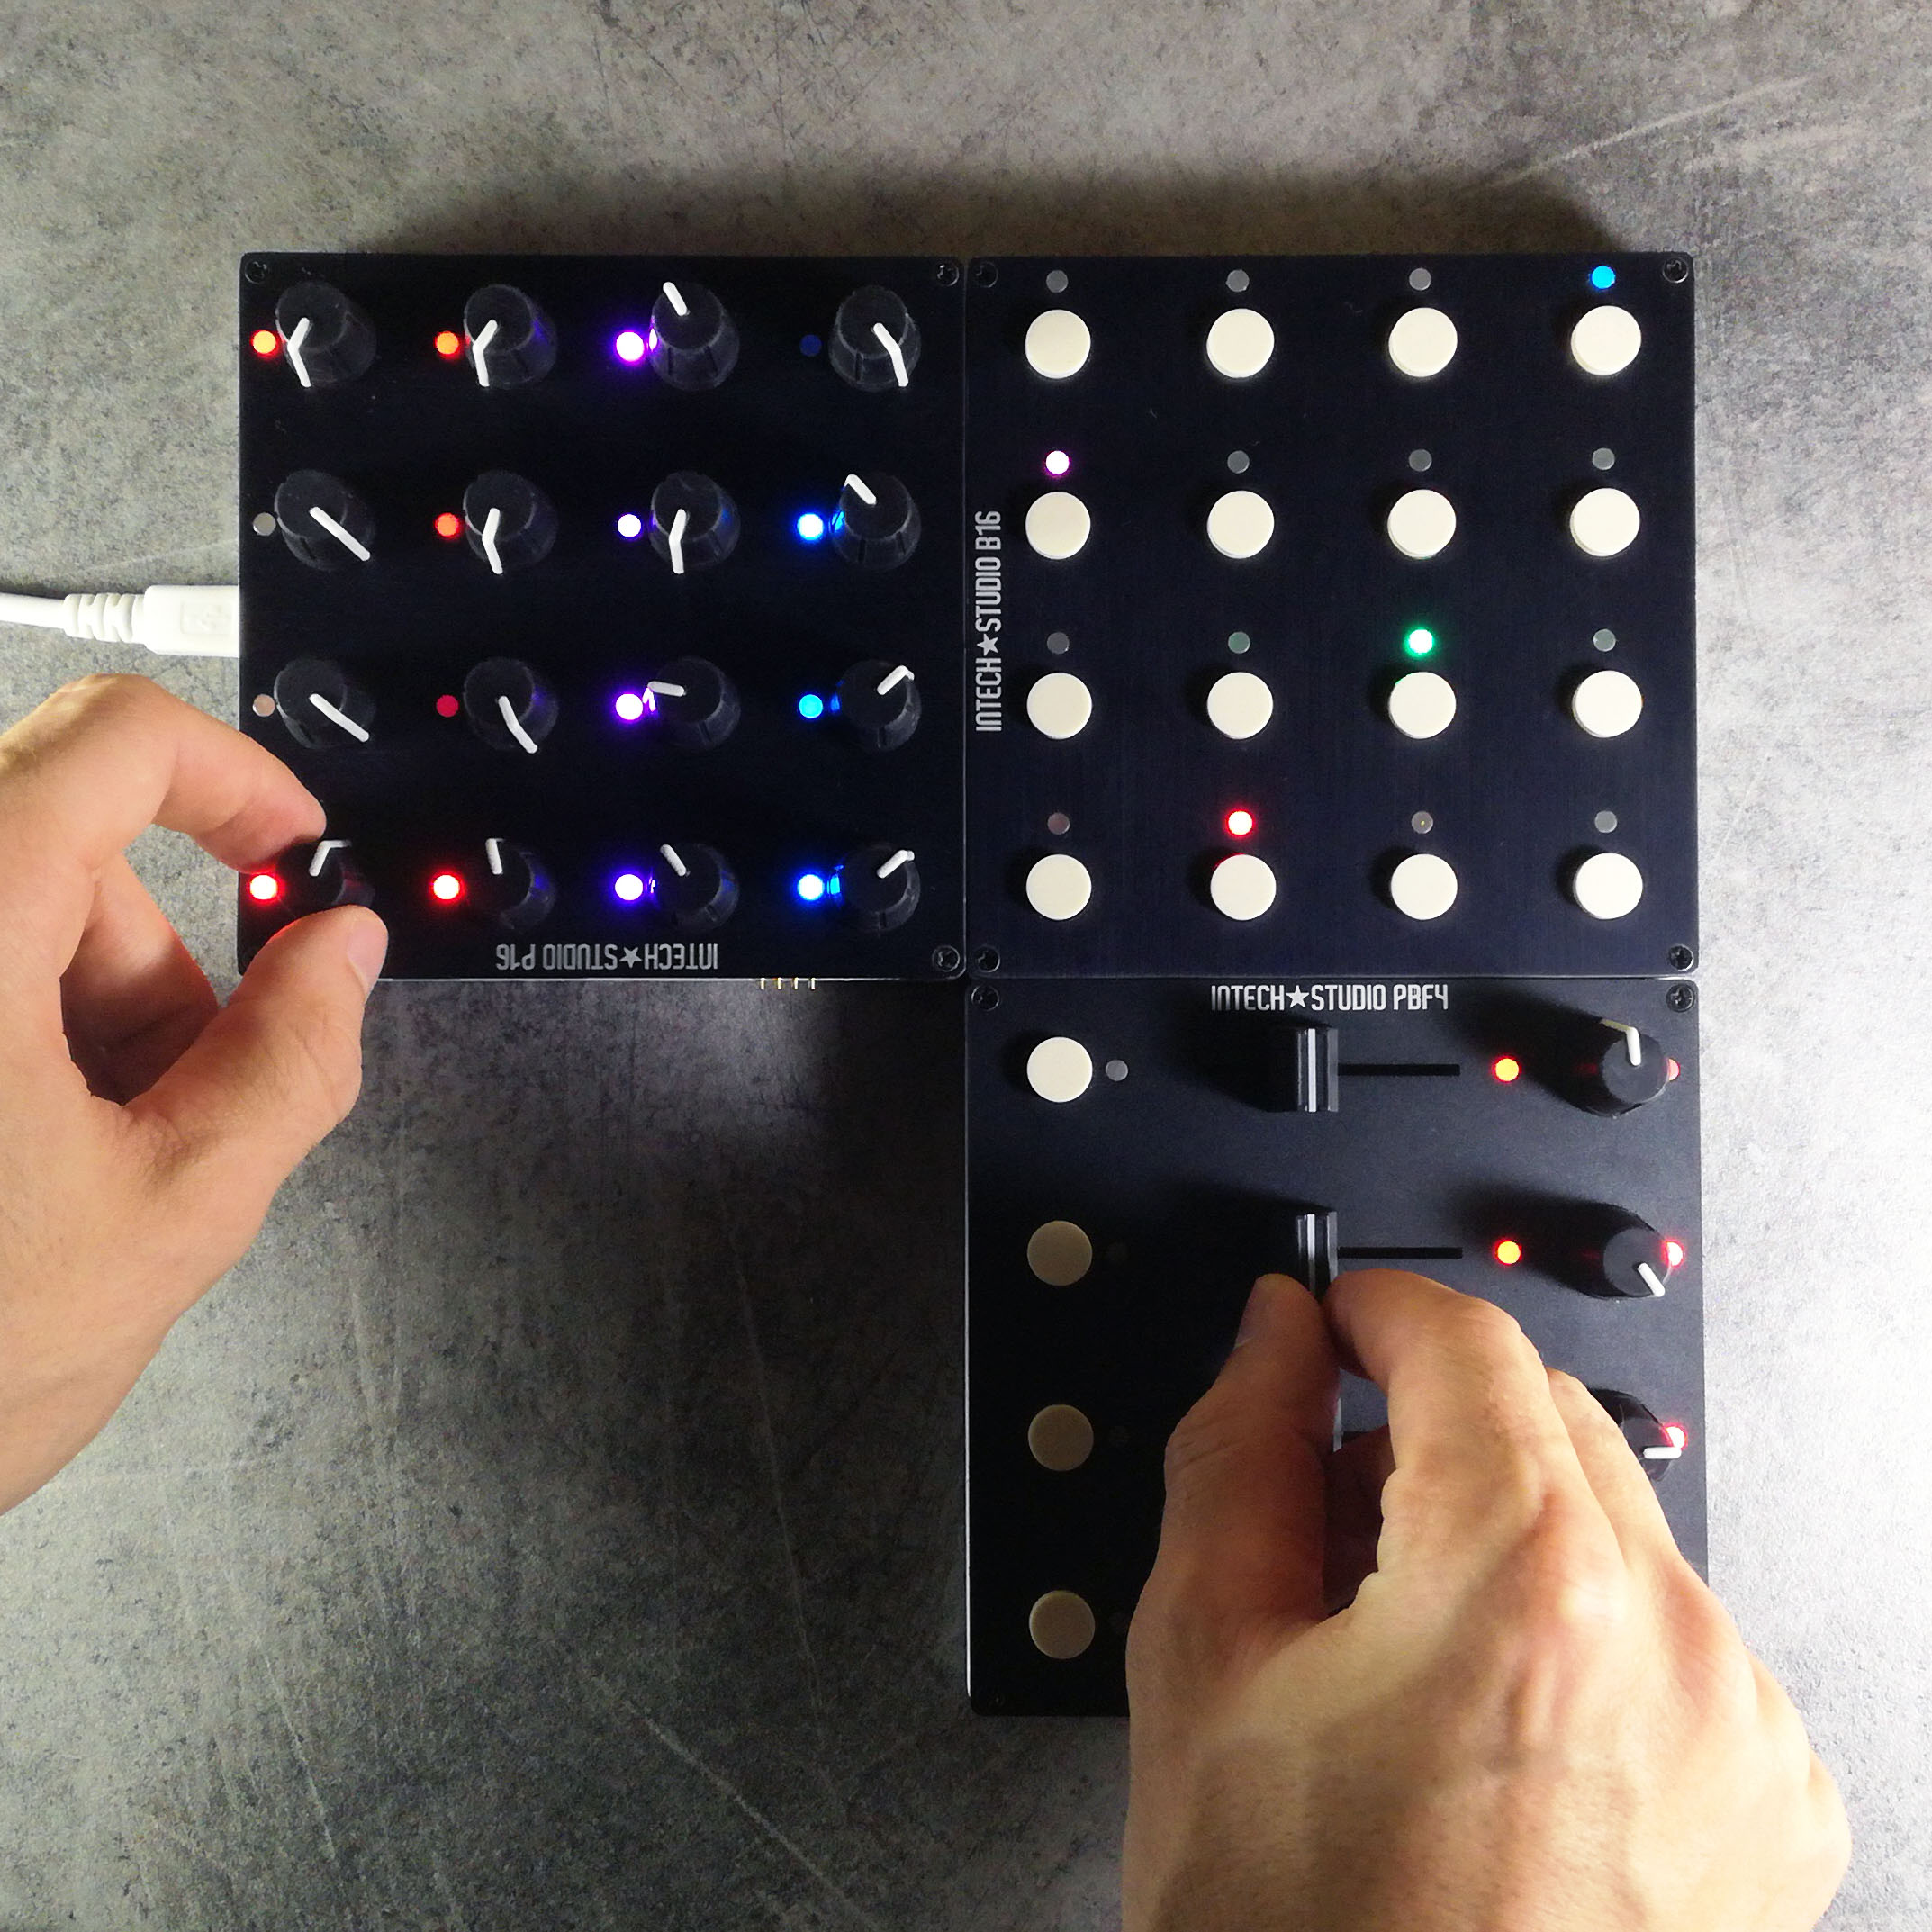Figure 1: P16, B16 and PBF4 prototype modules in use.
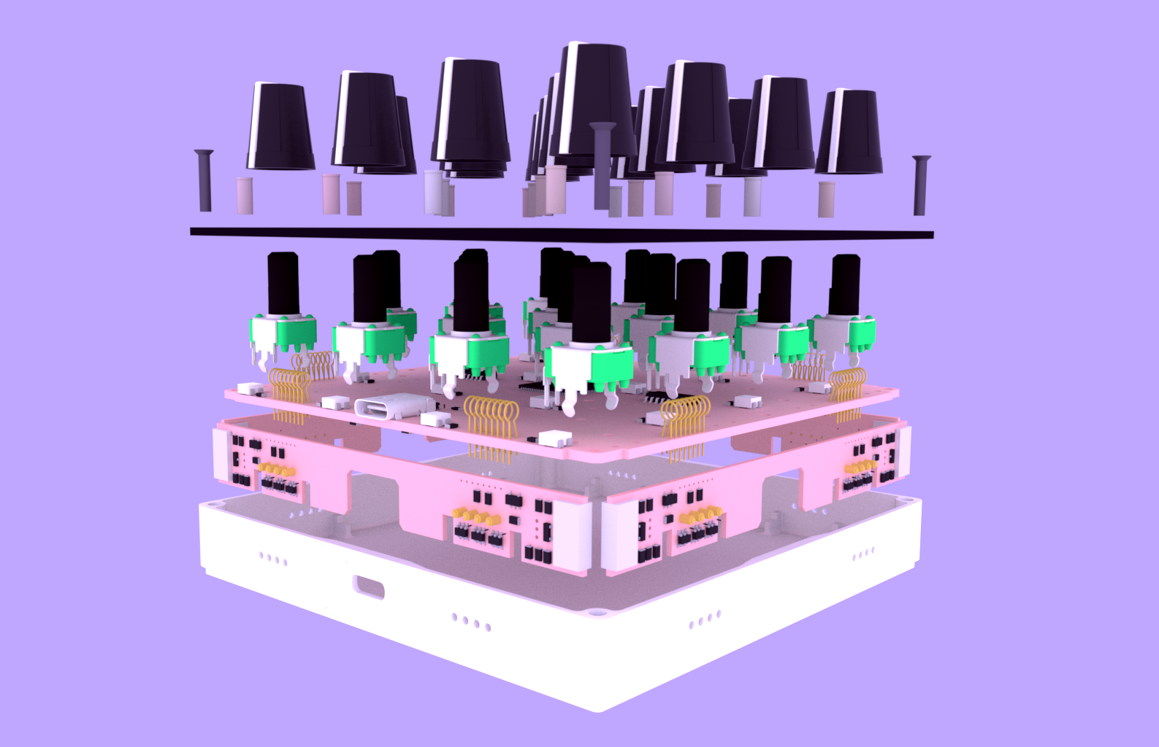Figure 2: Assembly drawing of the P16 module.
The modules are designed to be compatible with any other modules that we release in the future, regardless of the user interface. The control surface can be extended as the users needs change.
The challenges in creating Grid ecosystem include:
- Meeting strict design tolerances to ensure reliable functionality
- Maintaining backwards compatibility with new module
- Optimizing the cost of production and logistics
- Building a scalable product ecosystem

Grid Interface
The modules in the control surface connect to each other using the Grid Interface. Neodymium magnets are place in the corner of the modules, these allow the modules to snap together, making the control surface easy to reconfigure. Spring-loaded pogo pin connectors are installed on the sides of the modules, these provide power and data communication between the modules.
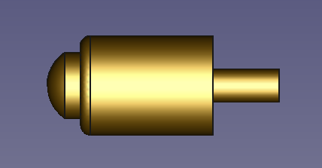Figure 3: Custom manufactured spring-loaded pogo pin connector.
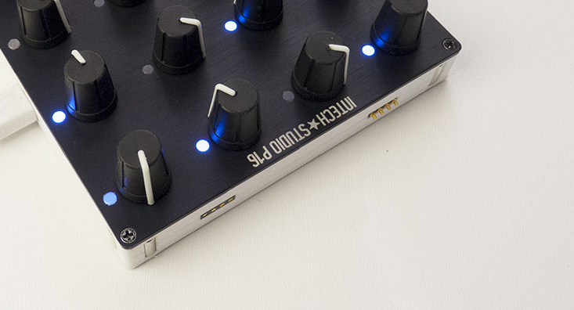Figure 4: Pogo pins and magnets on the side of the P16 prototype.
This wired point-to-point data and power interface allows neighboring modules to communicate independently. The Grid Interface also provides two global data lines for timing critical signaling. On this port the modules can broadcast messages to communicate to every other module simultaneously.
The Grid interface is automatically disabled when there is no neighboring module connected. This eliminates the chance of accidentally short circuiting the power supply. The interface detects a connection by recognizing the specific magnetic field produced by the neighboring module. This allows the user to reconfigure the control surface during use.
The Grid control surface connects to a host device via a single USB C cable. The power provided by the host has to be distributed throughout the Grid. Up to 20 modules can be connected to the host using a single USB C cable. The control surface can be extended further by connecting a USB C phone charger as secondary power source to the Grid.
The challenges in creating Grid Interface include:
- Designing suitable pogo pin connectors meeting the bandwidth and current requirements
- Ensuring long term reliability of the product
- Ensuring repeatability in the production.

Grid Protocol
The Grid Modules communicate using the Grid Protocol over the point-to-point network of full-duplex serial ports that run at 4Mbps. This is the primary data delivery network for the Grid.
The communication between the modules introduces inherent latency. This has to be low enough for the user to be unnoticeable, currently specified to be less than 1ms/link. The module farthest away from the USB Host will have the most round-trip latency, around 4-5ms in a typical configuration.
Two auxiliary channels are provided in the specification. These are half-duplex global data lines reserved for transmitting timing-critical messages, synchronization and global settings.
The challenges in creating such protocol include:
- Delivering all of the messages to every connected module in the control surface
- Implementing the network stack in a memory constrained embedded processor
- Achieving maximum possible data throughput while maintaining minimal latency
- Providing highly reliable error detection and error correction for every interface

Technical Specification Summery
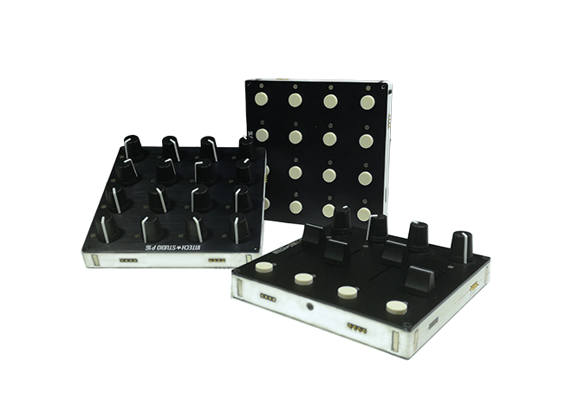
- Modular control surface
- Tactile user interface
- Full-color RGB LEDs
- High resolution inputs: 10 bit effective
- Aluminum front-panel
- Compact: 106mm x 106mm x 16mm
- 21 HP Eurorack compatible
- Light weight: 200g (7oz)
- USB C bus-powered device
- USB2.0 compliant (Audio Device Midi, CDC Serial, DFU)
- Compatible with Windows, Mac and Linux

